Assignment-4

CS544 Network Science

--------------------------------

Name: Sriram Pingali

Roll Number: 1801cs37

-----------------------------------

**Instructions**

**Attached is two .pynb files. One is the code for node2vec and the other uses node2vec for link prediction. Open the codes in google colab and understand the same. For the assignment you need to modify the node2vec algorithm. The modification is as follows: The random walker starts from a current node u. The choice of next node should now be biased towards nodes with degree similar to the current node. Test the performance of the modified node2vec algorithm on link prediction. Write a report that describes the modified node2vec algorithm and also compares its performance on link prediction. You should compare the performance based on precision, recall and F1 scores. Submit the codes in .ipynb as well as the report.**

**PART 1: Implementing degree biased random walker**

The weighted random walk strategy uses the weights corresponding to the edges which have the same degree as higher.

Weighting of edges is done as follows,

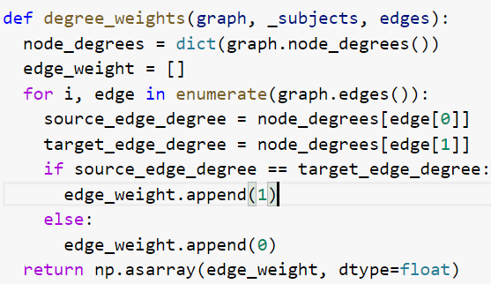

**PART 2: Comparing the Performance of the modified node2vec algorithm with the original algorithm.**

The significant decrease in the precision, recall and f1 score for all the features, operator_hadamard, operator_l1, operator_l2 and operator_avg used for link prediction when using the modified node2vec algorithm is clearly observed in the outcome.

|  |
| --- |
| A. Using original node2vec algorithm |

|  |
| --- |
| B. Using the modified node2vec algorithm |

There is a 30-40% decrease in accuracy for most of the cases is mainly because the weighting of the nodes doesn’t allow the random walker to explore newer nodes freely which does not produce good embeddings.

Therefore, the results that we obtain using the modified node2vec algorithm we can conclude that the original node2vec algorithm performs better than the modified.